
When choosing bedroom groups, we advise that friendship groups, behavioural issues and any vulnerable or isolated children are
considered. Additionally, you may want to consider the
locations of the nearest adult rooms, toilet facilities
and the fire escape when deciding who sleeps
where. Please include the names of all resident
and non-resident children and adults. To ensure
we can offer the maximum allowable beds the
Fen is now available as room of 6, and if
required staff can stay in the Mandeville
or alternatively, we can offer a ‘baby’
monitor for this room if requested.

Please complete and return this form to us 3 weeks before your visit via email (burwell.house@cambridgeshire.gov.uk). The number of attendees on this form will be used as the minimum number payable on the final invoice, even if the group size subsequently decreases. If there is any increase in group size, please inform Burwell House immediately, and we will do our best to accommodate this.

School Groups
Burwell House Bedroom Plan



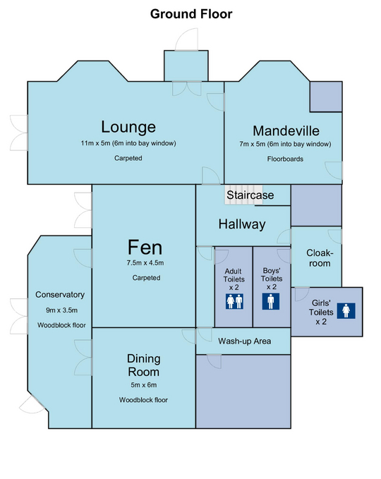
Burwell House Bedroom Plan

Burwell House Bedroom Plan
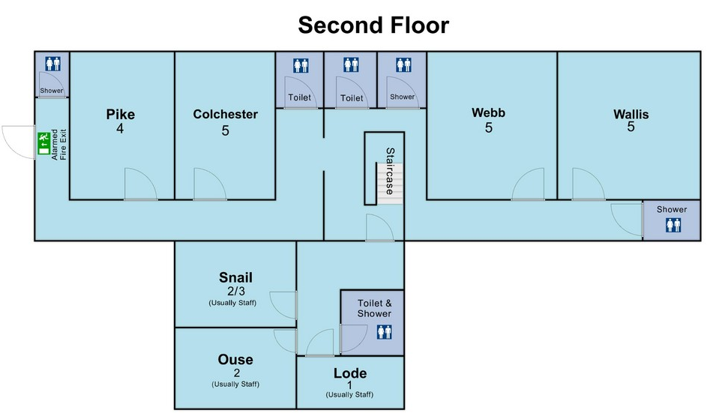
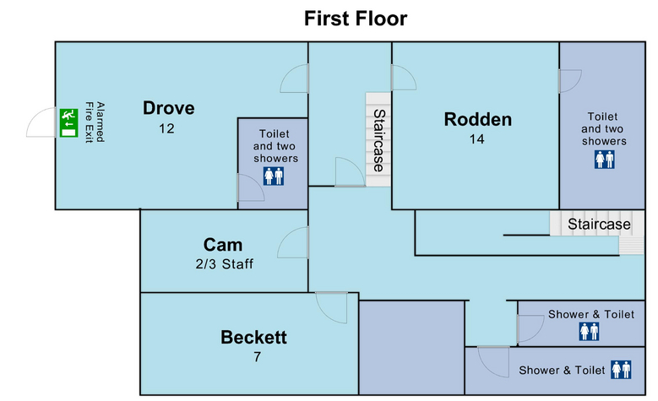
Burwell House Bedroom List
School Name: ……………………………………………………….
Resident Adults: …….. Resident pupils ….... Non-resident Adults ….... Non-resident pupils: …….
First Floor | Notes
Beckett (This room is the only children’s room directly next door to an adult room)
1
2
3
4
5
6
7
Drove (this room has direct (alarmed) access to the fire escape)
1
2
3
4
5
6
7
8
9
10
11
12
Rodden
1
2
3
4
5
6
7
8
9
10
11
12
13
14
Cam (Staff)
1
2
(3)
Non-residential adults and children
Second Floor | Notes
Pike (The corridor outside this room has close access to the alarmed fire escape)
1
2
3
4
Colchester
1
2
3
4
5
Webb
1
2
3
4
5
Wallis
1
2
3
4
5
Snail (Usually staff but can be 2 beds for children if required)
1
2
3
Ouse (Usually staff)
1
2
Lode (Usually staff)
1
Fen (This room is downstairs, next to the lounge)
1
2
3
4
5
6
Mandeville If required for 1 or 2 staff see notes regarding if required.
1
2
‘Baby’ monitor for Fen

Please add any notes into the column that may be useful to us e.g. Bed wetting (BW), Additional support (AS), etc.
Burwell House Individual Course Member
Information and Emergency Contact Details
(This sheet will be securely stored and destroyed upon departure)
Non-Residents

Name | Which days and times is the child attending? | Which meals are required?
Please complete the form below to advise us of which meals, days and times these day visitors will attend

Course Members’ Information

Please use this table to indicate any pupils who have special needs - including medical, behavioural or physical conditions - which it may be useful for Burwell house staff to be aware of. Visiting teachers should bring these pupils to the attention of their tutors at the start of the visit and confirm if they will have a 1 to 1 attending.

Please note – information on special diets should be on the meal planner and special diets form – please record these separately.
Name | Information | 1 to 1 attending

Emergency Contacts

Please provide emergency contact details for 2 members of key staff back at school – normally the head teacher, deputy head, chair of governors etc. These members of staff are to act as emergency contacts for on-site leaders and for Burwell House managers – accessible by telephone at all hours for the duration of the residential visit if the need arises.
They should have contact details for the parents/carers of all the children on the visit, as well as next of kin contacts for all visiting adults. Any parental / next of kin contact in the event of an emergency would normally be through this school contact rather than via the members of staff on site.
 | Name | Position | Contact Number
Emergency
contact 1
Emergency
contact 2

